CS 340 Project Two - Grazioso Salvare Dashboard
Becca Hammond October 19, 2025
Project Overview
Grazioso Salvare Animal Rescue Dashboard is a full-stack web application that enables Grazioso Salvare to identify and categorize dogs suitable for search-and-rescue training. The dashboard provides an interactive interface to filter, visualize, and analyze animal shelter data from the Austin Animal Center, helping the organization efficiently locate dogs with specific breed, age, and sex characteristics that align with different rescue operation types. The application follows the Model-View-Controller (MVC) design pattern. The model is the MongoDB database storing animal shelter data. The view is the dash framework providing interactive web interface with data tables and charts. The controllers are the python callbacks using the CRUD module to query and filter data.
Functionality & Screenshots
1. Reset (Unfiltered View)
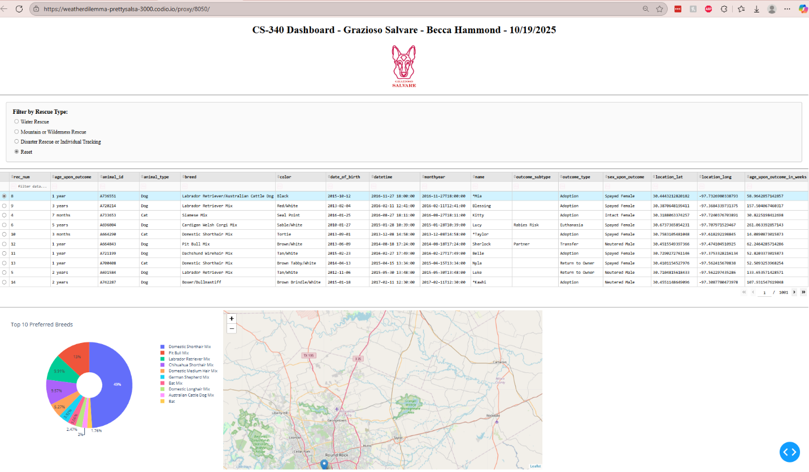
Default view showing all 10,000 animals in a paged view with interactive table, pie chart, and map.

2. Water Rescue Filter
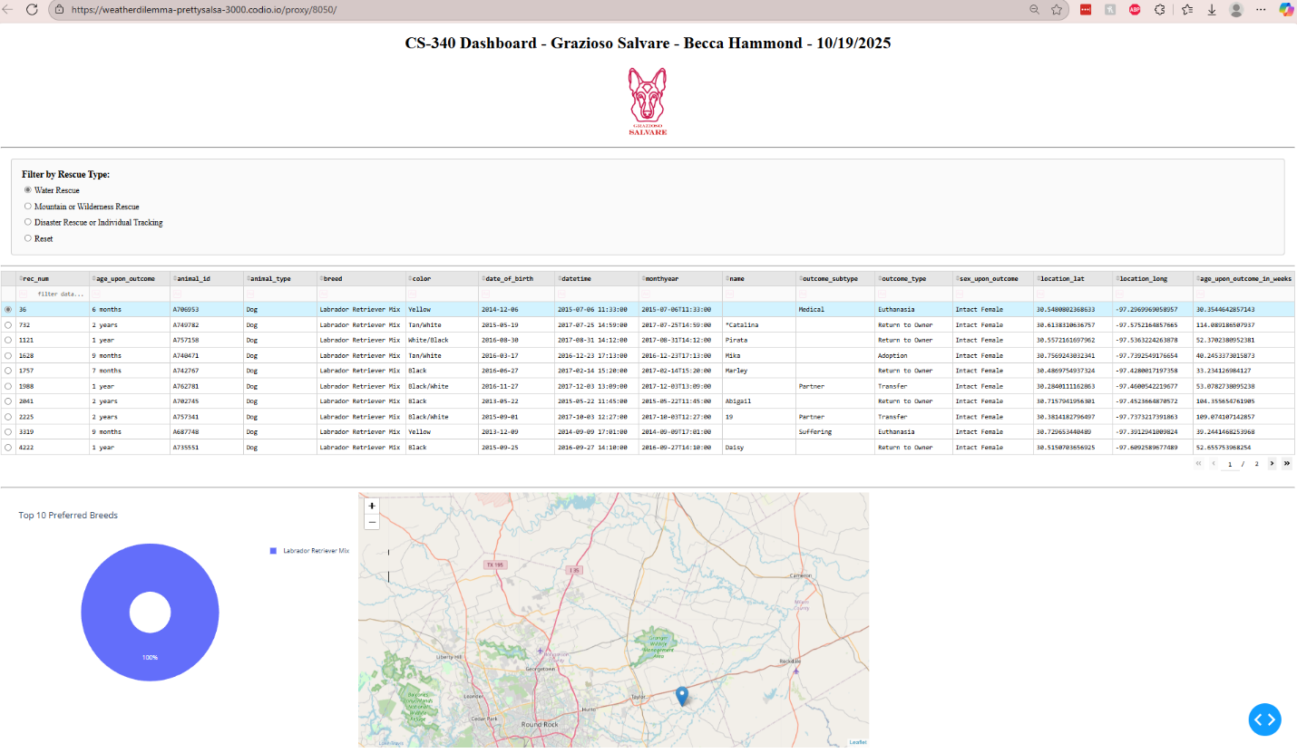
Water Rescue Filters for: Labrador Retriever Mix, Chesapeake Bay Retriever, Newfoundland, Intact Female, and 26-156 weeks in age.

3. Mountain/Wilderness Rescue Filter
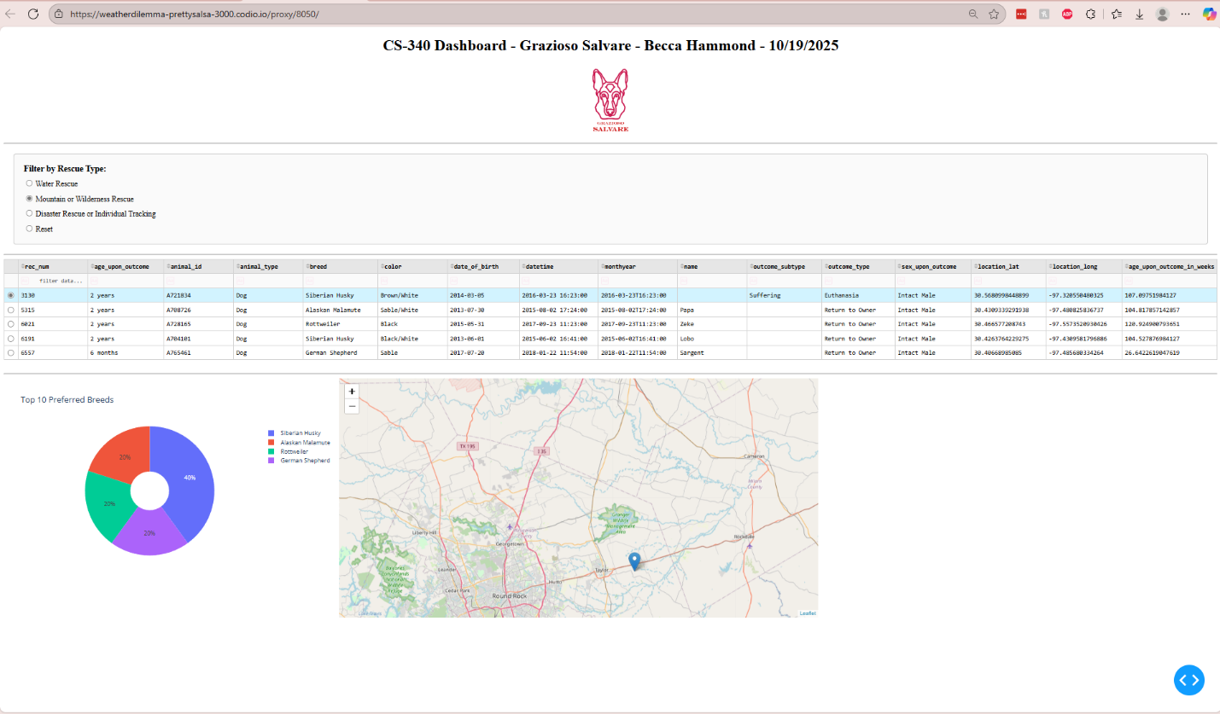
Mountain/Wilderness Rescue filters for: German Shepherd, Alaskan Malamute, Old English Sheepdog, Siberian Husky, Rottweiler, Intact Male and 26-156 weeks in age.

4. Disaster/Individual Tracking Filter
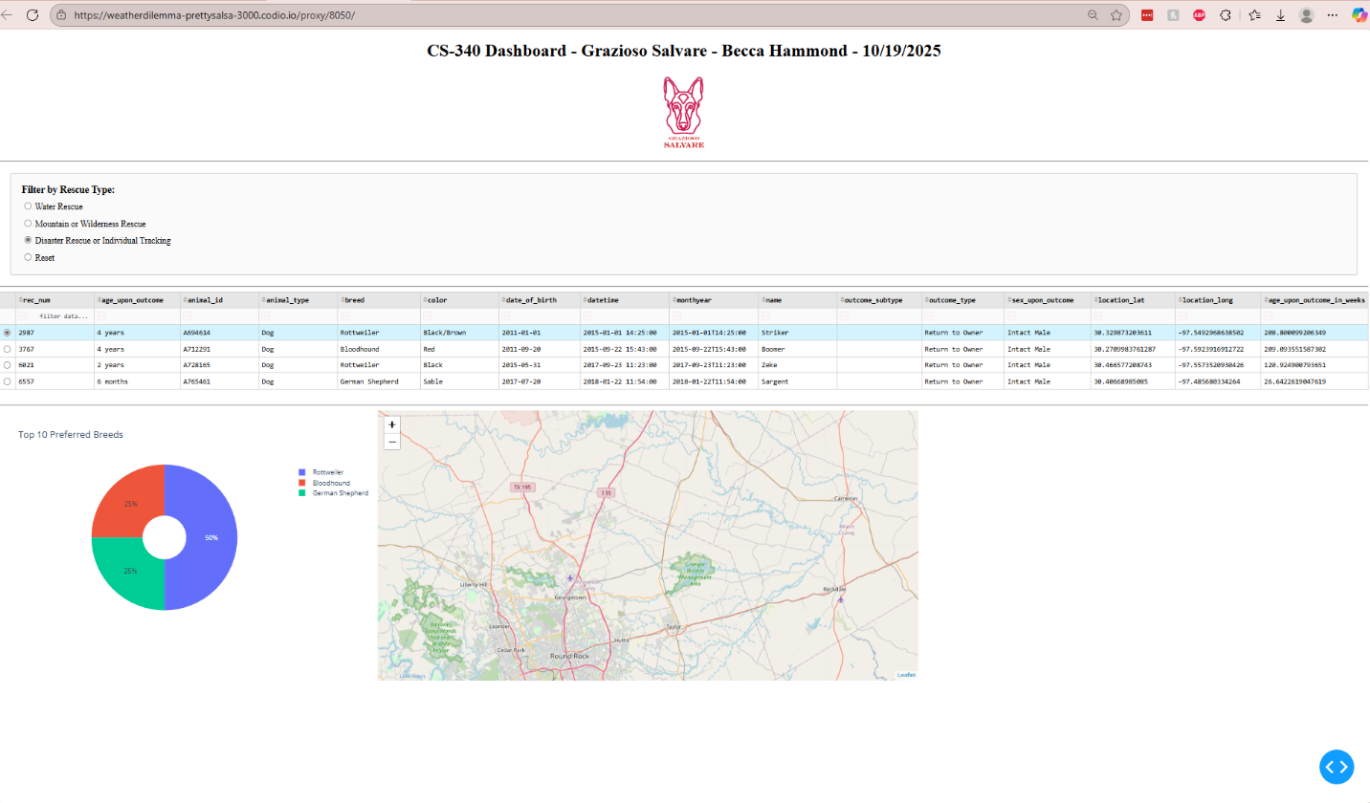
Disaster/Individual Tracking filters for: Doberman Pinscher, German Shepherd, Golden Retriever, Bloodhound, Rottweiler, Intact Male and 20-300 weeks in age.

5. Interactive Row Selection
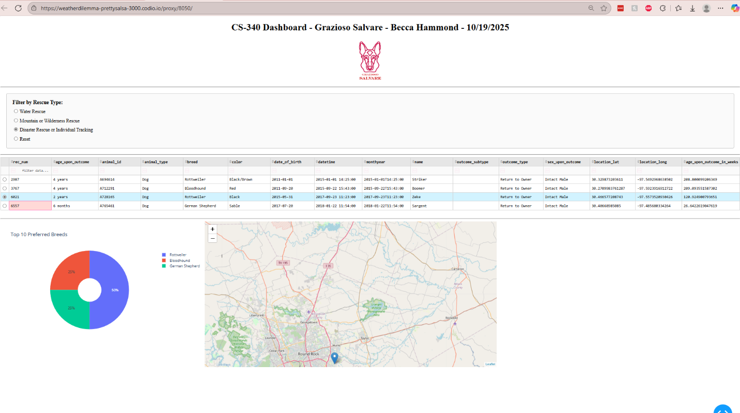
Selecting a row (3rd from the top vs 1st in screenshots) highlights it and updates the map to show that animal's location.
Tools & Rationale
MongoDB
- Flexible document model handles varying animal data fields
- Efficient querying with indexing for breed/age filters
- PyMongo provides seamless Python integration
Dash Framework
- Python-based (no JavaScript required)
- Built-in reactive callbacks for MVC pattern
- Interactive components (tables, charts, maps) out of the box
Python Libraries
- PyMongo: MongoDB database driver
- Pandas: Data manipulation and conversion
- Plotly: Interactive visualizations
- Dash Leaflet: Map components
Installation & Setup
Install dependencies:
bash pip install pymongo pandas plotly dash jupyter-dash dash-leaflet

Import data to MongoDB:
bash mongoimport --type=csv --headerline --db aac --collection animals aac_shelter_outcomes.csv

Create database user:
bash mongosh
use admin
db.createUser({user: "aacuser", pwd: "MmmFood", roles: [{role: "readWrite", db: "aac"}]})

Run dashboard:
- Open ProjectTwoDashboard.ipynb in Jupyter Lab
- Run all cells
- Access dashboard at http://localhost:8050/

Steps to Complete Project
- Database Setup - Imported data and created CRUD module (Project One)
- Basic Dashboard - Built data table and map (Module Six)
- Filter Implementation - Added radio buttons and MongoDB queries for rescue types
- Visualizations - Added pie chart for breed distribution
- Integration - Connected all components through Dash callbacks
- Testing - Verified all filters and interactions work correctly

Challenges & Solutions
- Challenge 1: Callback Errors
  - Changed selected_columns to selected_rows input and fixed row highlighting callback.
- Challenge 2: Map Not Displaying
  - Modified callback to return valid HTML components instead of None.
- Challenge 3: Column Access
  - Switched from column indices to column names (dff.loc[row, 'location_lat']) for reliability.
- Challenge 4: Query Syntax
  - Used MongoDB $in operator for breed matching and $gte/$lte for age ranges.

Contact
Becca Hammond
Email: rebecca.hammond3@snhu.edu
GitHub: @beccahammond

